**Steps to run the application:**

1. Run the SQL script, present in root directory.
2. Open appsettings.json file and change the connection string

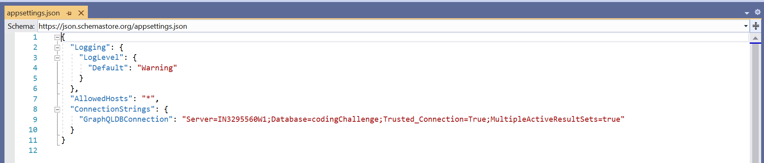

1. Click on IIS Express button

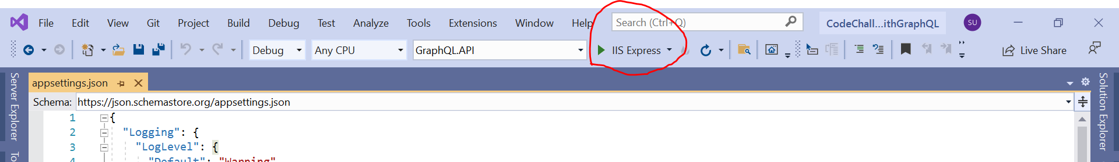

1. Below screen will appear then we can put our input in left pane and can see the output in right pane.

